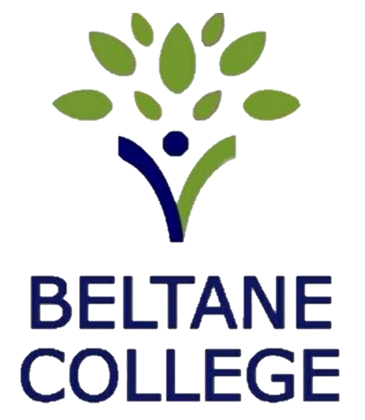

Complaints and Compliments Policy

Member Responsible for Policy |  | Director of People and Strategy
Version | THREE | Last Updated | August 2026
Approving Directors |  | DP, BS
Date of Next Review |  | August 2029

Policy Intent and Scope
Beltane College values the voices of our students, families, staff and wider community. This policy sets out a clear, fair and transparent process for sharing compliments or raising concerns about any aspect of our provision. It explains how we will respond at each stage, what you can expect from us, and the limits of what this policy covers, ensuring clarity for all parties.
This policy applies to concerns about the college’s practice, environment, communication, or the delivery of support and education as outlined in a student’s Education, Health and Care Plan (EHCP). It does not replace statutory safeguarding procedures, whistleblowing processes, or formal staff grievance routes.
If your concern relates to a qualification, assessment decision or awarding-body process, you must follow the relevant awarding organisation’s complaints or appeals procedure.
Staff members wishing to raise a concern about their employment should follow the separate Staff Grievance Policy.
Audit and Governance
Complaints are logged and monitored by college managers and reported annually to the Governing Body. A governor will be invited to sit on the panel for formal complaints or appeals, ensuring independent oversight and compliance with the SEND Code of Practice, Equality Act 2010 and data-protection legislation.

The process

Stage 1 – Informal Compliments or Complaints
Informal compliments or complaints refer to routine comments or concerns raised in relation to day-to-day experiences. These matters are typically addressed promptly through constructive dialogue, with the aim of maintaining a positive educational environment and supporting student wellbeing and progress.

Resolution Approach
Informal concerns are usually resolved through conversation and agreed next steps. This may include sharing good practice, clarify expectations, or take proportionate action to address the issue.
Where a compliment is shared, staff will ensure it is acknowledged and passed on appropriately.

Record-Keeping
Where appropriate, informal feedback that results in an action or relates directly to an individual student’s progress or wellbeing will be noted on the student’s record. General comments that do not require follow-up are not formally logged.

Handling Feedback on Staff or Practice
Feedback relating to individual staff members or college practice will be reviewed by the directors, who will determine any appropriate internal action.
To maintain confidentiality and ensure proportionate handling, outcomes of informal feedback will not be reported back to the complainant. A summary of informal complaints and compliments will be included in the annual report to governors to support oversight and continuous improvement.

Stage 2 – Formal Complaints
Formal complaints relate to significant concerns that require a structured, documented and impartial process. This stage ensures transparency, fairness and timely communication, while maintaining confidentiality and safeguarding the wellbeing of all involved.

Submitting a Formal Complaint
Formal complaints must be submitted in writing and addressed to the Head of Learning via email. Students and parents may request support to draft their complaint; however, the content must be expressed in the complainant’s own words to ensure accuracy and authenticity.

Escalation Pathways
If the complaint concerns the Head of Learning, it should be addressed to the Directors and submitted via: ContactUs@BeltaneCollege.co.uk
If the complaint concerns a director, it should be addressed to the Chair of Governors using the same email address.

Acknowledgment of Receipt
The Head of Learning (or relevant recipient) will acknowledge receipt of the complaint within three working days. The acknowledgment will outline the next steps and provide an indicative timeline for an investigation.

Investigation Process
The investigation may include:
- A phone call to clarify the nature of the complaint and understand the concern.
- Meetings with relevant parties to gather information and explore the context.
- A review period to consider all perspectives and determine an appropriate response.
- A written outcome (email or letter) stating whether the complaint has been upheld, partially upheld, or not upheld.
- Where applicable, a summary of actions or next steps arising from the decision.
Outcome details will be shared with the complainant; however, personal or sensitive information relating to staff or other students will not be disclosed. Any internal actions taken because of the complaint will remain confidential and will only be shared on a need-to-know basis.

Timeline
The college aims to complete the formal complaints process within ten (10) working days of receipt. If a more detailed investigation is required, the complainant will be informed of the delay and provided with a revised timeline.

Final Stage – Right to Appeal
If a complainant is dissatisfied with the outcome of a formal complaint, they may request an appeal. The appeal stage provides an opportunity to review whether the formal process was conducted fairly, proportionately and in line with this policy. It is not a re-investigation of the original complaint, but a review of whether the decision-making process was sound.

Submitting an Appeal
Appeals must be submitted in writing within five (5) working days of receiving the formal complaint outcome. Appeals should be addressed to the College Directors at: ContactUs@BeltaneCollege.co.uk, with Appeal Submission clearly stated in the subject line.
The appeal should outline the specific grounds for reconsideration. Grounds may include:
- A procedural error in the handling of the formal complaint
- Relevant evidence that was not considered
- Concerns that the decision was not reasonable based on the information available
Appeals should focus on points that were not addressed or adequately considered during the original investigation.

Acknowledgment and Review
Receipt of the appeal will be acknowledged within five (5) working days.
The Directors (or Chair of Governors, where appropriate) will conduct a review, which may include:
- Re-examining documentation from the formal complaint
- Consulting relevant parties where clarification is required
- Considering whether the process and decision were fair, proportionate and aligned with policy
The appeal review will not involve re-interviewing all parties unless essential for clarity.

Outcome and Timeline
A decision will normally be communicated within ten (10) working days of acknowledgment. If additional time is required to ensure a fair evaluation, the complainant will be informed and provided with a revised timeframe.
The final response will state whether the appeal is
upheld,
partially upheld,
not upheld,
along with a brief explanation of the decision and any next steps where relevant.

Conclusion
The appeal decision is final, and no further internal recourse is available.
Data Protection Statement
We handle all complaints in line with UK GDPR and our Data Protection Policy. Formal written complaints will be retained for an appropriate period (normally up to five years) to support accountability, quality assurance and, where necessary, compliance with legal or regulatory requirements. Complaint records are stored securely and accessed only by staff with a legitimate need to do so.

