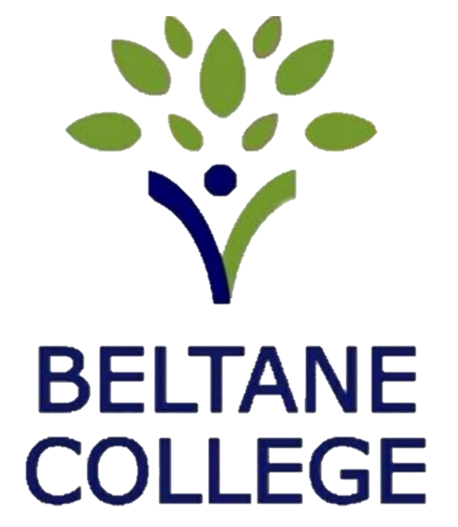

Data Protection Policy

Member Responsible for Policy |  | Director of Business and Finance
Version | Two | Last Updated | August 2026
Approving Directors |  | RBW, DP,
Date of Next Review |  | August 2028

Intent
Beltane College is committed to full compliance with UK data protection legislation, including the UK GDPR and Data Protection Act 2018, and to upholding the highest standards of ethical practice.
This policy governs the processing of personal data in both manual and electronic formats and outlines the College’s approach to:
• Responding to data breaches
• Upholding individual rights under UK GDPR

Governance and Oversight
The Director of Business and Finance serves as the College’s Data Protection Officer (DPO). All data-related enquiries should be directed to the DPO.
Policy Access and Communication
To promote awareness and compliance:
• The policy is published on the College website
• It is shared with all new staff during induction

Data Collection and Use
The College collects and processes personal data to fulfil:
• Contractual obligations (e.g. payroll, attendance)
• Legal duties (e.g. tax, benefits)
• Educational responsibilities (e.g. safeguarding, student support)
Where appropriate, data may also be processed for legitimate interests such as equality monitoring, with anonymisation applied where possible.
We are committed to:
• Transparency in data collection and sharing
• Ensuring accuracy, relevance, and secure storage
• Retaining data only as long as necessary
• Responding to Subject Access Requests within legal timeframes
• Ensuring staff understand their responsibilities

Individual Rights Under UK GDPR
Individuals have the right to:
• Be informed about data use
• Access, correct, or request deletion of their data
• Restrict or object to processing (where permitted)
• Withdraw consent (if applicable)
• Challenge automated decisions and lodge complaints with the ICO
These rights may be limited when data is processed under legal, contractual, or public interest grounds.

Data Security and Breach Management
Staff responsibilities:
• Keep data secure (digital and paper-based)
• Avoid unauthorised disclosure
• Open confidential communications only if addressed to them
• Use College email and addresses for work purposes only
Examples of breaches:
• Unauthorised access or disclosure
• Data sent to the wrong recipient
• Lost or stolen devices
• Unlawful data changes or loss of access
Reporting protocol:
• Report suspected breaches immediately to the DPO
• Submit a breach report—do not investigate independently
• The DPO will assess, record, and notify the ICO within 72 hours if required
• Affected individuals will be informed and preventative measures applied

Subject Access Requests (SARs)
Requests must be made in writing (including email) to the DPO and include:
• “Subject Access Request” in the subject line or heading
• Date of request
• Full name (including aliases if relevant)
• Identifying information used by the College
• Up-to-date contact details
• Clear scope and timeframe of requested data
• Preferred method of receiving the response

Verification:
Proof of identity is required (e.g. passport, driving licence, utility bill). The College may request additional details if the scope is unclear.
Response time:
Requests will be fulfilled within 30 calendar days, extendable by two months for complex cases. Excessive or unfounded requests may be refused or incur a fee.
Disclosure:
Redacted data will be retained for audit purposes. All disclosures will be legible, with codes or technical terms explained.

Training and Support
All staff will receive training on data privacy and protection.
Further guidance is available from the Information Commissioner’s Office (ICO) at ico.org.uk or by calling 0303 123 1113.

Related Legislation
• UK General Data Protection Regulation (UK GDPR)
• Data Protection Act 2018
• ICO Codes of Practice

