

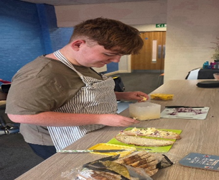
A love of learning reignited!
Nathan joined Beltane unsure and anxious. He wasn’t sure what to expect from education after a difficult mainstream experience. He knew he wanted to grow, but needed a place where he felt understood, seen, and supported.

When Nathan visited Beltane, the team asked him who he was, not just what he struggled with. They listened, explored his strengths, and personalised a timetable to match his confidence level, his interests, and long-term goals.
“I am seen for who I am… At Beltane I am seen for me and not for my medical condition.”
Nathan felt recognised and with each new opportunity, his confidence grew. He embraced practical learning, community experiences, and independence-building that helped him prepare for his next steps.
Nathan benefitted from;
Practical outdoor work experience, building flower beds, using power tools, and developing teamwork with the Canal & River Trust and PLANT MCR
Independent living skills, budgeting, shopping, and preparing nutritious meals, with signature dishes that earned him comparisons to Jamie Oliver
Route training, now confidently using public transport independently
Personal project, exploring his interest in history through visits to the People’s History Museum, The Imperial War Museum and Manchester’s cenotaphs
Career exploration, discovering real-world ambulance service careers and the skills for success at the Northwest Ambulance Service Careers event
Community confidence, navigating new environments, meeting new people,
and building friendships

With Beltane’s support, Nathan is turning his growing independence into a future he’s excited about. He has progressed to a Supported Internship, where he will gain hands-on experience in a hospital setting, a meaningful step toward his ambition of working within the ambulance service.
“Nathan needed to fall in love with education again, and Beltane has done that. Well done to the Beltane team, you have a phenomenal provision.” – Nathan’s mum

